In our comprehensive study on the impact of discounts on profits across diverse business sectors, we employed a systematic approach. Starting with the selection of a relevant dataset and key columns like 'Order_Item_Discount_Rate,' 'Order_Item_Total,' and 'Order_Profit_Per_Order,' we utilized K-means clustering to unveil patterns. Visualizations through bar charts complemented this, providing insights. Further analysis with decision trees allowed us to identify critical factors in the intricate relationship between discount rates and profit. This systematic process offers businesses clear insights and actionable guidance for refining discount strategies and optimizing overall performance.

**Cluster Analysis:**

In navigating the intricacies of our dataset, we strategically opted for the K-means clustering algorithm, prized for its efficiency and scalability. Acting as a sorting mechanism, K-means grouped similar data points together, a crucial step given the multidimensional nature of our dataset with numerous influencing factors. To maintain a balanced contribution from each variable, we implemented standardization using the StandardScaler. This transformation leveled the playing field, preventing any single variable from disproportionately influencing the clustering process. The pivotal task of determining the optimal number of clusters followed, akin to categorizing data into meaningful groups. The silhouette score, a metric assessing the distinctiveness and separation of each cluster, guided this decision-making process. By selecting the cluster number that maximized the silhouette score, we ensured a meaningful and insightful grouping of our data, avoiding clusters that were too broad or overly complex.

In essence, our approach involved a deliberate selection of the robust K-means tool to efficiently organize our data. The emphasis on fairness through variable standardization and the strategic use of silhouette scores allowed us to strike the right balance in grouping our data. This meticulous process serves as the foundation for a nuanced understanding of inherent patterns in our dataset, laying the groundwork for subsequent analysis and interpretation.

Visualization of clusters:

In our pursuit of utmost clarity and interpretability, we transformed our analytical findings into visually intuitive representations. Our meticulous approach is exemplified through a carefully constructed bar chart that unveils the average distribution rates within each identified cluster.

By examining the specific code outputs, we observe that our clustering analysis resulted in four distinct clusters. Cluster 0, characterized by a discount rate of 0.175, reflects a strategy that is notably different from Cluster 1, where the discount rate is 0.050. Similarly, Cluster 2 exhibits a distinct approach with a discount rate of 0.1, while Cluster 3 follows with a rate of 0.075. These numerical representations form the basis of our visual narrative, offering a clear depiction of the nuanced discount rate strategies prevalent across various business sectors.

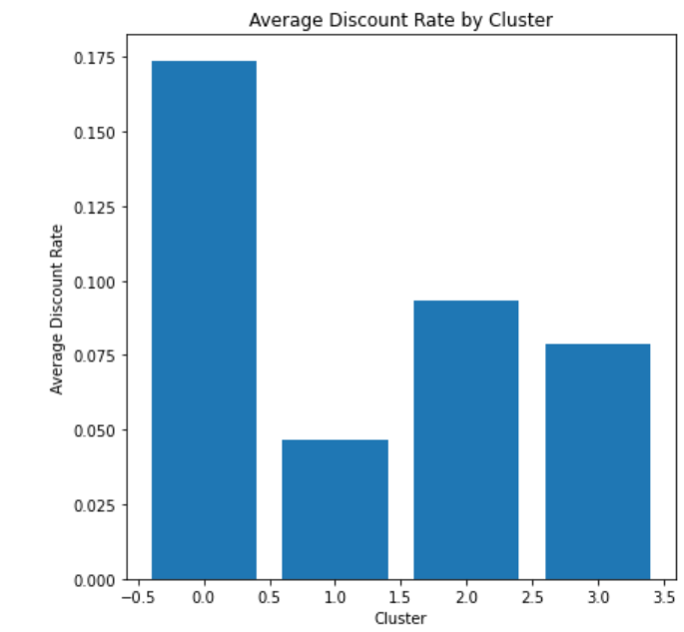  
 Figure 1: Visualization of Average Discount Rate by Cluster

Furthermore, our commitment to comprehensive visualization extends to a combined bar chart, where the holistic distribution of total sales and profit across these identified clusters comes to light. Delving into the specifics of this graph, we observe that Cluster 0 and Cluster 1 share similar sales amounts (0.8), and their profits are also equivalent (0.2). On the other hand, Cluster 2 portrays a distinct pattern with a lower sales amount (0.2) and no recorded profit. Meanwhile, Cluster 3 emerges as a standout performer with the highest sales amount (1.3) and a commendable profit of 0.3.

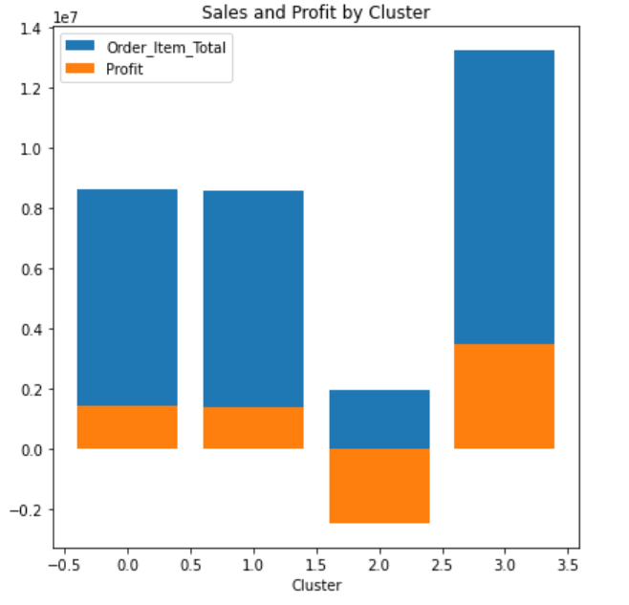  
Figure 2: Visualization of Sales and Profit by Cluster

Results/Findings:  
The findings emphasize how crucial it is to grasp the subtle connections between discount rates, sales, and profit. Clusters 0 and 1 show us that finding a sweet spot between offering discounts and maintaining profitability is doable. On the other hand, Cluster 2 signals a need to take a closer look at how our discounting strategy might be affecting our profits—it's like shining a spotlight on that area for improvement.

Now, let's talk about Cluster 3—it stands out as a positive example. It suggests that when we get the balance right in our discounting strategy, we can see a big boost in both sales and profits. This kind of insight lays the groundwork for smart decision-making in business strategy. Building on these points, these insights aren't just interesting facts—they're like building blocks for making better decisions. Businesses can use this information to fine-tune how they offer discounts, aiming for that sweet spot that keeps customers happy while still bringing in solid profits. It's like having a roadmap to guide businesses toward making choices that can lead to better financial performance.

**Regression Analysis using Decision Trees**

In our ongoing analysis, we employed regression analysis with decision trees to uncover the nuanced relationship between discount rates and profits within identified clusters. Tailoring our models to the unique characteristics of each cluster, we adopted a cluster-specific strategy to ensure precision in capturing the distinct dynamics at play within diverse business sectors. This meticulous approach, using 'Discount Rate' as the input feature ('X') and 'Order_Profit_Per_Order' as the target variable ('y'), provided granular insights, steering clear of broad generalizations. The resulting visualizations, including decision trees, scatter plots, and regression lines, offer a holistic perspective, equipping decision-makers with nuanced insights for optimizing discounting strategies tailored to the specific characteristics of each cluster.

Visualization:

Figure 3: Scatter plot with Decision tree Prediction – Cluster 3

Figure 4: Scatter plot with Decision tree Prediction – Cluste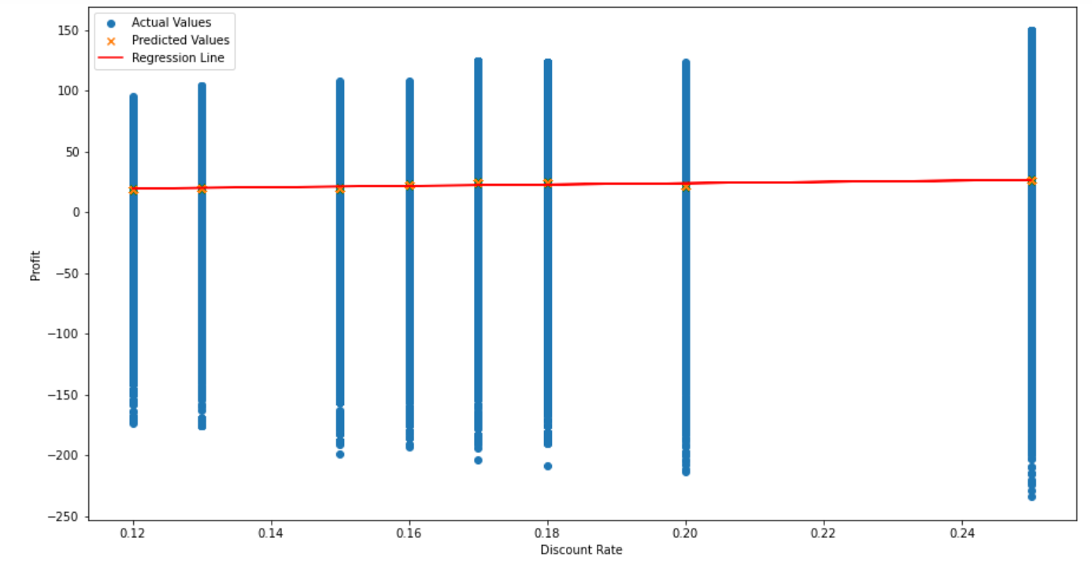  
Figure 5: Scatter plot with Decision tree Prediction – Cluster 0

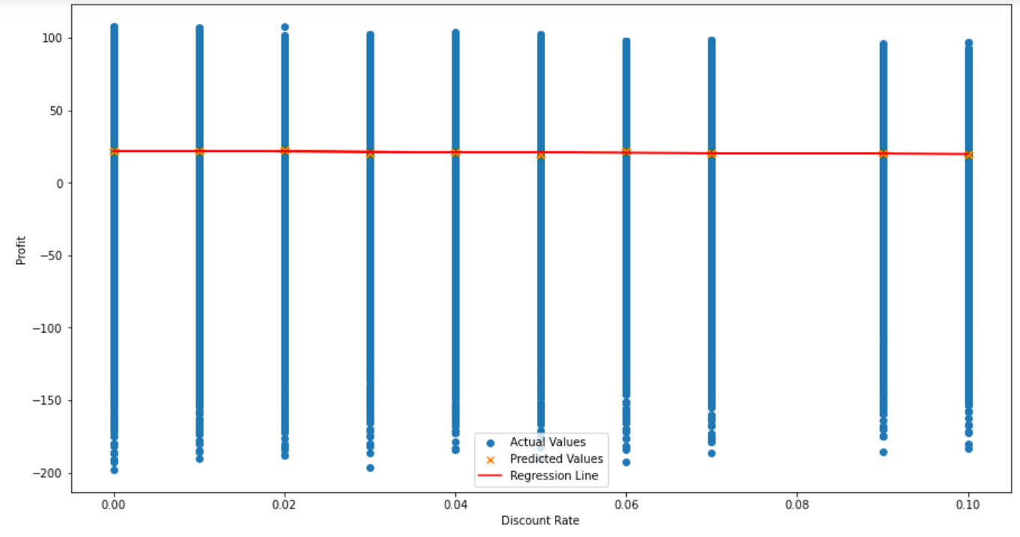  
Figure 6: Scatter plot with Decision tree Prediction – Cluster 1

In the visualizations, it's intriguing to note that for Clusters 0 and 1, where the predicted values hover around zero, it may seem like discount rates have a minimal impact on profitability. However, it's essential to consider an alternative perspective: while the predicted values appear consistent, it doesn't necessarily imply a lack of influence. Instead, these clusters might present an opportunity for optimizing discount strategies to potentially increase profits without a significant change in the predicted values. On the contrary, Cluster 3, with its positive linear trend in predicted profit values aligning with higher discount rates, suggests that, in certain contexts, strategic discounting could indeed contribute to profit growth. In the case of Cluster 2, where discounts seem to correlate with losses, a closer examination of discounting strategies may unveil opportunities to mitigate these negative impacts and turn them into positive outcomes. These insights underscore the importance of not just dismissing discount rates' apparent influence but rather leveraging strategic discounting to enhance profitability within each specific business context.

Results/Findings:

The results gleaned from the visualizations indicate intriguing dynamics within different clusters. While Clusters 0 and 1 suggest a seemingly limited impact of discount rates on profits, there exists an opportunity for optimizing discount strategies to potentially increase profits without a substantial change in the predicted values. Conversely, Cluster 3 reveals a positive correlation between higher discount rates and increased profitability, suggesting strategic discounting may contribute to profit growth in certain contexts. Notably, Cluster 2 highlights the need for a nuanced approach, as discounts seem to correlate with losses; however, a closer examination of discounting strategies may reveal opportunities to mitigate negative impacts. These findings underscore the complexity of discount-rate dynamics and the potential for strategic adjustments to positively influence profits within distinct business sectors.

**Recommendations**

In light of our comprehensive analysis, tailored recommendations emerge to guide industries in optimizing their discounting strategies. unveils unique insights, prompting nuanced approaches for retailers to fine-tune their tactics, industries to strategically leverage discounts for profitable growth, and businesses to mitigate losses through refined discounting strategies. These recommendations aim to empower stakeholders with actionable insights, fostering a data-driven and context-specific approach to discounting for enhanced profitability.

Optimizing Discount Strategies for Retailers:

For retailers operating in Clusters 0 and 1, where the visualizations indicate a seemingly modest impact of discount rates on profits, there's an opportunity to fine-tune discount strategies. Instead of outright eliminating discounts, retailers can experiment with targeted promotions, personalized offers, or loyalty programs to maintain customer engagement and potentially increase profits without significantly altering the predicted values. This approach aligns with the notion that subtle adjustments in discounting tactics, rather than complete elimination, can lead to improved financial outcomes. A data-driven strategy, incorporating customer segmentation and purchase behavior analysis, could be instrumental in tailoring discounts to specific customer segments and maximizing their impact on profitability.

Strategic Discounting for Profitable Growth:

For industries falling within Cluster 3, characterized by a positive correlation between higher discount rates and increased profitability, the recommendation is to strategically leverage discounting as a tool for stimulating sales and achieving profitable growth. Businesses can consider implementing dynamic pricing strategies, time-limited promotions, or bundling options to encourage larger purchases and capitalize on the observed positive relationship between discounts and profits. Additionally, a comprehensive analysis of customer response to varying discount levels can inform a more targeted and effective discounting strategy, ensuring that the positive impact on profitability is sustained over the long term.

Mitigating Losses and Enhancing Profitability:

In the case of Cluster 2, where discounts appear to correlate with losses, a nuanced approach is essential. Industries within this cluster should conduct a thorough examination of their discounting strategies, aiming to identify and rectify factors contributing to negative outcomes. This might involve reassessing pricing structures, refining product offerings, or implementing targeted marketing campaigns to shift the observed trend from losses to profits. Moreover, exploring alternative approaches such as value-added services, upselling, or cross-selling could help mitigate losses associated with discounting and contribute to a more balanced and profitable operational model. The key takeaway is that for all clusters, the strategic alignment of discounting practices with specific business contexts is paramount for optimizing profitability.